**NAME…………………………………………….........… .........CLASS……………………….**

**ADM NO…………………… INDEX NO………………………..... DATE: …………………**

**231/1**

**BIOLOGY**

**PAPER 1**

**THEORY**

**JUNE 2024**

**TIME: 2 HOURS**

**KASSU JET EXAMINATIONS**

***Kenya Certificate of Secondary education***

**BIOLOGY PAPER I**

**JUNE 2024**

**2 HOURS**

**Instructions**

* Write your name, class and admission number in the space provided above.
* Write the date of the examination in the space provided above.
* Answer all the questions in the spaces provided.

**For Examiner’s use only**

|  |  |  |
| --- | --- | --- |
| **QUESTION** | **MAXIMUM SCORE** | **CANDIDATE’S SCORE** |
| **1 – 32** | **80** |  |

*This paper consists of 10 printed pages.*

*Candidates should check the question paper to ascertain that all the pages are printed as indicated and no questions are missing.*

1. (i) Some herbaceous stems have very little strengthening tissue yet still remain upright.

Explain. (2 marks)

..................................................................................................................................................

..................................................................................................................................................

..................................................................................................................................................

(ii) Name the strengthening material in sclerenchyma (1 mark)

..................................................................................................................................................

1. State the functions of the following structures of the human brain. (3 marks)
2. Cerebrum

..................................................................................................................................................

..................................................................................................................................................

1. Cerebellum

..................................................................................................................................................

..................................................................................................................................................

1. Medulla oblongata

..................................................................................................................................................

..................................................................................................................................................

# 3. The diagram shows a simple reflex arc.

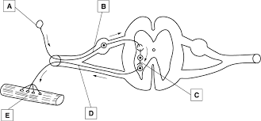

Explain how an impulse is transmitted across the gap between neurons C and D (3 marks)

..................................................................................................................................................

..................................................................................................................................................

..................................................................................................................................................

..................................................................................................................................................

1. (a) Based on the structure available on this diagram classify this type of stem. (1 mark)

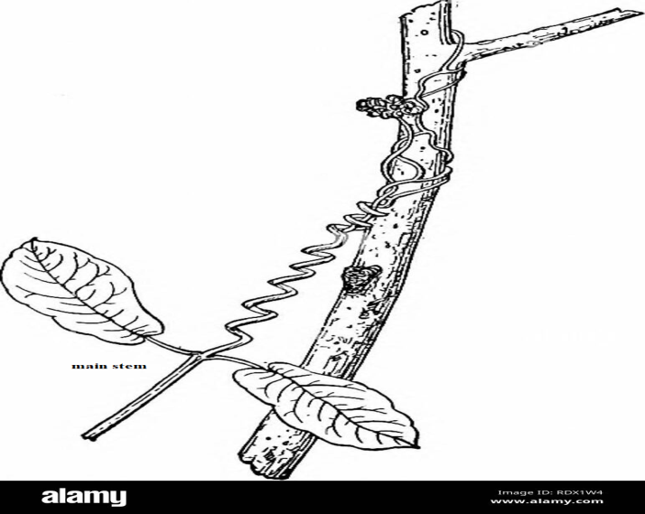

..................................................................................................................................................

(b) How is the other type of stem different from this one? (1 mark)

..................................................................................................................................................

1. State the importance of tactic responses among some members of kingdom Protoctista. (1 mark)

..................................................................................................................................................

..................................................................................................................................................

1. State two differences between tropisms and taxes. (2 marks)

|  |  |  |
| --- | --- | --- |
|  | **Tropisms** | **Taxes** |
| (i) |  |  |
| (ii) |  |  |

1. Explain continental drift as an evidence of evolution. (2 marks)

..................................................................................................................................................

..................................................................................................................................................

..................................................................................................................................................

1. Why are some bacteria able to resist the effect of antibiotics? (2 marks)

..................................................................................................................................................

..................................................................................................................................................

..................................................................................................................................................

..................................................................................................................................................

1. The diagram below illustrates the arrangement of bones and muscles in the human arm.

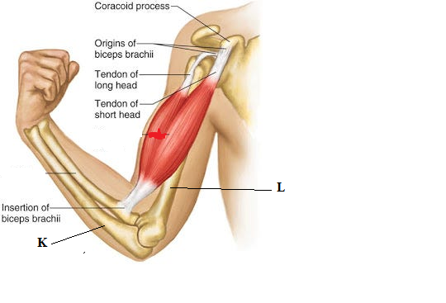

(i) Name the bone labelled K (1 mark)

K ……………………………………………………………………………..

(ii) Explain how the upward movement of the lower arms is brought about by the bones and muscles shown in the diagram above. (2 marks)

…………………………………………………………………………………………..………………………………………………………………………………………..……………………………………………………………………………………………………………

1. Jerry’s blood crystallizes at low oxygen concentration. He is married to Janice whose blood does not crystalize in low oxygen concentration. Work out the probability of the couple producing children with the same fate as their father Jerry. Use the letter d to denote for crystallization at low oxygen. (4 marks)
2. State the causative agents for the following diseases
3. Syphilis.................................................. ................................... (1mark)
4. Trichomoniasis .............................................. ........................ (1mark)
5. What do you understand by the term ecological niche? (1mark)

..................................................................................................................................................

..................................................................................................................................................

1. The diagram below shows the feeding relationship between rabbits and wolves in a given habitat over a period of 25 years. Study it and answer the questions that follow

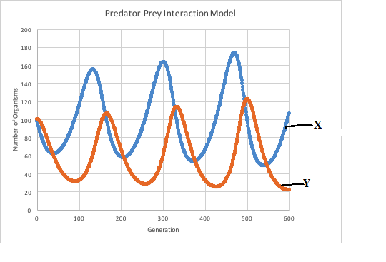

1. Name the type of feeding relationship. (1mark)

…………………………………………………………………………………..

1. Which organism in the relationship above is represented by the curve labeled X and Y (2 marks)

X ………………………………………………………………………………..

Y ………………………………………………………………………………..

1. The diagram below represents a human reproductive organ.

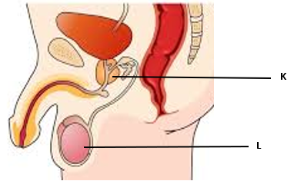

(i) State **two** adaptations of the structure labelled L to its functions. (2 marks)

..................................................................................................................................................

......................................................................................................................................................................................................................................................................................................................................................................................................................................................

(ii) Explain the role of the role of the gland labelled K (1mark)

..................................................................................................................................................

..................................................................................................................................................

1. The diagram below shows different developmental stages of a given organism.

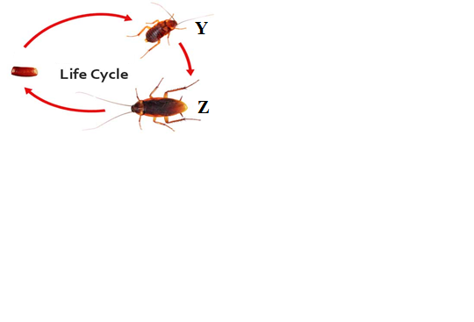

(a) Identify the stages represented by letter Y and Z (2 marks)

Y ………………………………………………………………………………….

Z …………………………………………………………………………………………..

(b) Identify the hormones which play a role in the above process and state where they are produced (2 marks)

|  |  |
| --- | --- |
| **Hormone** | **Site of production** |
|  |  |
|  |  |

15. State the mode of asexual reproduction in yeast (1 mark)

..................................................................................................................................................

16. Name **two** substances that leave the foetal blood through the placenta into maternal blood stream. (2 marks)

..................................................................................................................................................

..................................................................................................................................................

17. Besides venation, State **two o**ther external characteristics of leaves that can be used to classify plants. (2 marks)

..................................................................................................................................................

..................................................................................................................................................

..................................................................................................................................................

18. The graph below shows the concentration antibodies produced during a primary infection and secondary infection against time. Study the graph and answer the question below.

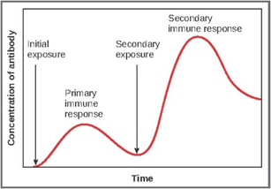

(a) Name the type of immunity illustrated by the graph (1 mark)

..................................................................................................................................................

(b) In a blood test a few drops of anti-B serum were added to two samples of blood separately. No agglutination occurred in either of them. What were the blood groups of the two samples (2 marks)

..................................................................................................................................................

..................................................................................................................................................

19. (a) State two ways in which opening of the stomata is important to plants (2 marks)

..................................................................................................................................................

..................................................................................................................................................

..................................................................................................................................................

(b) Explain how accumulation of carbon (IV) oxide in a leaf affects the stomata (3 marks)

..................................................................................................................................................

..................................................................................................................................................

..................................................................................................................................................

..................................................................................................................................................

20. Explain each of the following observations:

(a) The stump of a severed tree trunk may exude copious quantities of fluids after cutting

(1 mark)

..................................................................................................................................................

..................................................................................................................................................

(b) Leaf fall reduces the rate of transpiration (1 mark)

..................................................................................................................................................

..................................................................................................................................................

(c) The xylem tissue is made up of dead tissue (1 mark)

..................................................................................................................................................

..................................................................................................................................................

21. (a) During the process of respiration, the breakdown of glucose occurs in phases. Explain why these phases are necessary?

(2 marks)

..................................................................................................................................................

..................................................................................................................................................

..................................................................................................................................................

(b) Explain why the rate of production of lactic acid increases during exercise

(2 marks)

..................................................................................................................................................

..................................................................................................................................................

..................................................................................................................................................

22. Explain why body temperature regulation is more difficult in a hot humid conditions

(2 marks)

..................................................................................................................................................

..................................................................................................................................................

..................................................................................................................................................

23. Suggest **two** ways in which plants compensate for lack of complex excretory organs

(2 marks)

..................................................................................................................................................

..................................................................................................................................................

24. State **two** factors that would lead to a decrease in the rate of photosynthesis. (2 marks)

..................................................................................................................................................

..................................................................................................................................................

..................................................................................................................................................

1. Knowledge and skills acquired in the course of studying biology are very important. Justify the above statement. (2 marks)

..................................................................................................................................................

..................................................................................................................................................

..................................................................................................................................................

1. The ileum is highly coiled in mammals, State **two** biological significance of this feature?

(2 marks)

..................................................................................................................................................

..................................................................................................................................................

..................................................................................................................................................

..................................................................................................................................................

1. Caecum is part of the digestive system of some herbivores. What is its role in digestion?

(1 mark)

..................................................................................................................................................

..................................................................................................................................................

1. The diagram below is that of a certain plant tissue.

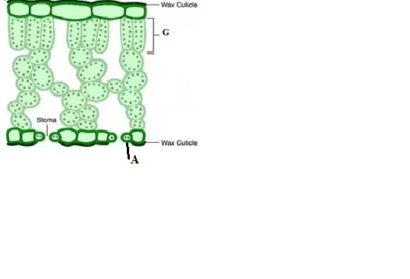

1. Name the structures labeled G. (1 mark)

..................................................................................................................................................

1. State **two** adaptations of the specialized cell labeled A to its functions? (2 marks)

..................................................................................................................................................

..................................................................................................................................................

..................................................................................................................................................

..................................................................................................................................................

1. A student was viewing a slide prepared of an epidermal cell under medium power objective lens. The specimen appeared blurred. Which part of the microscope would the student adjust to obtain a clearer view? (1mark)

..................................................................................................................................................

1. (i) Define active transport. (1 mark)

..................................................................................................................................................

..................................................................................................................................................

..................................................................................................................................................

(ii) Why are the following factors important in the process of active transport in cells:

1. Oxygen (1 mark)

..................................................................................................................................................

..................................................................................................................................................

1. Optimum temperature (1 mark)

..................................................................................................................................................

..................................................................................................................................................

1. (i) Suggest a likely habitat of an organism with an active contractile vacuole.

(1 mark)

..................................................................................................................................................

(ii) Give a reason for your answer above. (1 mark)

..................................................................................................................................................

..................................................................................................................................................

1. How is dark stage of photosynthesis dependent on light stage? (2 marks)

..................................................................................................................................................

..................................................................................................................................................